FIRST Technical
Challenge
Safety Manual

A Team 2220 Blue Twilight Safety Outreach initiative
Version 4, January 2019

With review by: Green Girls Robotics FTC 7190, Solid Robotics FTC 11488, CrushBots FTC 11299, Thunder PengWin Robotics FTC 11150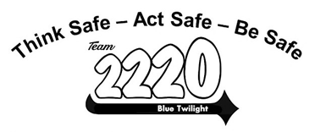

Introduction

This manual is a designed to bring the basic elements of industrial safety to FTC teams. Safety is everyone’s responsibility and a valuable life skill so while initial training will be conducted by the team mentors, ongoing safety presentations and safety monitoring functions will be performed by the students to build skills and a culture of safety on the team.

Culture of Safety (from the FIRST Safety Manual)
“Instilling a culture of safety is a value that every individual in the FIRST community must embrace as we pursue the mission and vision of FIRST. FIRST Robotics Competition has adopted safety as a core value and has established the framework for safety leadership in all aspects of the program. FIRST believes that the teams that take the lead in developing safety programs and policies have a positive and lasting impact on each team member and mentor, in addition to their communities and present and future work places.”

Why does Safety Matter?
- If you do not operate or participate in a safe manner, you could be seriously injured, disabled, or killed.
- Your unsafe actions could harm others.
- If anyone on the team is seriously injured, the team may not be allowed to continue.
- If other schools see reports of injured students on robotics teams, they may be less likely to participate.
- In industry, you could be disciplined or fired from your job for working in an unsafe manner.
FTC Team Members (adapted from the FIRST Safety Manual)
Be familiar with this document, as well as understand and follow established safety requirements applicable to your environment.
- Work in a safe and responsible manner.
- Use personal protective equipment (PPE), safeguards, and other safety equipment as required.
- Identify and report any unsafe or hazardous conditions or actions to a FTC coach or mentor.
- Encourage safe behaviors in everyone around you.

FTC Mentors(adapted from the FIRST Safety Manual)
- Lead by example. Practice the same safety behaviors that are expected from the students.
- Don’t work on the robot except if needed to show or teach a safety aspect.
- Provide guidance and encouragement on a safe working environment.
- Provide leadership and guidance on matters of general safety, including:
  - the use of personal protective equipment including during the lifting, handling and transportation of robots as detailed in this manual, and
  - in team work and practice spaces
  - at events.
- Utilize hazard-based safety engineering principles with team members to eliminate or minimize identified hazards to a safe level.

Table of Contents

Section A: Safety Basics
- Basic Shop Safety
- Emergency plans
- Safety Equipment
- Robot Safety
- Safety Contract

Section B: Pre-Kickoff
- Hazard Assessment Checklist
- Safety Training
- Safety Quiz

Section C: Safety Training by Students
- Safety Glasses
- Batteries and Chargers
- Hand Tools
- Power Tools
- Soldering
- Ladders
- Safety at Competitions

Section D: Appendix
- Safety Checklist for Build Area
- Corrective Action Form
- Safety Data Sheets

Section A: Safety Basics

Section A.1: Basic Shop Safety

- ALWAYS wear proper safety glasses in the shop, playing field and the pits!
- Wear closed toe and closed heel shoes.
- Tie back long hair.
- Do not wear loose clothing or jewelry.
- Wear gloves, hearing protection and a respirator when needed.
- No running or horseplay.
- Use the right tool for the job.
- Know how to use a tool, ask for help or get training.
- Do not use any tool unless you have been trained to use it.
- Have a coach or mentor present when operating any tool.
- Do not use tools that are dull or not in good condition.
- Work on a stable surface and watch out for sharp edges.
- Avoid distractions and do not distract others while working with tools.
- Do not leave power tools running unattended and leave the workspace in a safe condition when your work is complete.
- Keep workspaces clear and clean them when finished working.
- Know the emergency exits/plans for wherever you go.

SPECIFIC to EAGAN HIGH SCHOOL SHOP
- When using any of the shop tools team members must have an experienced mentor (on the tool that is being used) with him/her during tool usage.
- Proper safety glasses are required in the shop and playing field
- If you don’t know the right tool to use or how to use a tool find an experienced mentor.
- Shop must be clean and in the same condition as when practice started.
- Move tables back to locations they were, stools on the table and whiteboards erased (do not write over or erase any of the shop information that is on the whiteboards)

Section A.2: Emergency Plans

- Find the emergency exits for your workspace and competition area
- Know the evacuation plan for your team (building and transportation)
- Get an evacuation buddy

Section A.3: Safety Equipment

- Fire Extinguisher - Know where it is located and understand how to use it properly.
- First Aid Kit - Each team should have a kit and check the contents periodically. For EHS Robotic.
- SDS (Safety Data Sheet) - For every chemical used by the team a binder of SDSs should be readily available. Students should know what is in an SDS and how to find important information.

Section A.4: Robot Safety

- Don’t put your hands in or around the robot while it is energized or running.
- Turn off the robot and relieve all sources of stored energy when not using it or before working on it.
- Notify people and stand back before the robot is powered on.
- Don’t drive the robot too close to people.
- Use proper lifting techniques, including gloves. Lift with the knees, not your back
- Wear safety glasses
- Keep electrical wires restrained and away from moving parts

Section A.5: Safety Contract

After Sections A.1 through A.5 are reviewed with the students, have each of them sign the FTC Safety Agreement.
FTC Safety Agreement

FTC Safety Mission Statement:
To provide the tools, training and oversight for FIRST FTC teams to operate in a safe manner in all aspects of their work, including in the build area and at competitions. To establish a lifelong culture of safety within the team and spread that culture to other FIRST teams and the community.

Safety Principles and Student Expectations:
- Wear safety glasses at all times when in the shop, at playing field, in the pit, working on the robot, or whenever tools are being used.
- Wear closed-toe and closed-heel shoes, tie back long hair, and have no loose clothing or jewelry when working in the shop or on the robot.
- If you have not been trained to use a tool, ask to be trained – DO NOT try to use the tool yourself.
- You must be supervised while using all tools no matter how simple the task or how experienced you are. Never work alone.
- Always use the proper tool for the job.
- Do not use broken or damaged tools – keep them in good condition.
- Always ask for help whenever you need it.
- Be sure to learn about and wear the proper PPE for the job.
- Avoid distractions and don’t distract others while working with tools.
- Always clean up your workspace after use.
- Know where these items are and how to use them:
Fire extinguisher, First Aid Kit, FTC Safety manual with SDSs
- Report any unsafe situations you encounter.
- Report and document all injuries and near misses.

I have participated in the Safety Training, I have read and understand the FTC Safety Manual and I will follow all of the safety practices and principles to keep myself and others safe at all times.

Name (print) __________________________________________
Signature __________________________________________
Date _____________________________
Section B: Pre-Kickoff

Section B.1: Hazard Assessment Checklist

Review the list below and mark an X in the box for any of the items that your team uses to build the robot. Add additional items as necessary.

- Robot Batteries and chargers
- Hand Tools: screwdrivers, wrenches, hammers, saws, etc.
- Power Tools: drill press, band saw, belt saw, grinder, table saw, mills, CNC machines, etc
- Razor blades and other cutting tools
- Lubricants, adhesives and solvents
- Soldering irons
- Ladders
- Other – anything else that may be or cause a hazard

___________________ ____________________
___________________ ____________________
___________________ ____________________
___________________ ____________________

Section B.2: Safety Training

For the items you checked on the Hazard Assessment Checklist in Section B.1, use the information in Section C to conduct training and review proper use of the materials and equipment.

Section B.3: Safety Quiz

After the students have been trained on the materials and equipment that are to be used, the students should take a quiz where they are required to pass with 100% correct (students can review each wrong answer with their team coach and it will be considered correct if they demonstrate sufficient knowledge of the topic).

Section C: Safety Training by Students

This section is meant to be conducted by the students on the team. Each student will research their safety topic and present a brief overview and demonstration for the rest of the team.

Section C.1: Safety Glasses

Students should research safety glasses to understand which type to wear, how to keep them clean and how to store them to prevent scratching

Section C.2: Batteries and Chargers

Students should research the battery and charger used on their robot to understand the possible hazards they present and how to use and store them safely.

Section C.3: Hand Tools

Students should research the possible hazards of the hand tools used by the team, what PPE is necessary when using them and how to store them safely.

Section C.4: Power Tools

Students should research the possible hazards of the power tools used by the team, what PPE is necessary when using them and how to store them safely.

Section C.5: Soldering

Students should research the possible hazards of soldering irons if used by the team, what PPE is necessary when using them and how to store them safely.

Section C.6: Ladders

Students should research the possible hazards of ladders used by the team and demonstrate the buddy system (one person is on the ladder while another hold it securely).

Section C.7: Safety at Competitions

- Bring your Safety Equipment, SDSs and PPE.
- Use the buddy system when traveling and while at the event.
- Find the emergency exits for your competition area and have the the evacuation plan for your team building on your phone or in your pocket.
- Note that FIRST staff and volunteers are distinguished by their name badges.
- Travel safely and carefully between the pit and the playing field.
- Demonstrate safe behaviors at all times, even in the heat of competition.
- Establish a planned, safe lifting and transport procedure for the robot.
- Make sure the robot is properly secured and de-energized when you work on it. Never work on the robot on an unstable surface.
- Assist and mentor other teams with safety issues.
- Notify your mentors or FIRST personnel about any safety related issues you encounter.

Section D: Appendix
Section D.1: Safety Checklist for Build Area
Teams should periodically review the condition of the inspected area per the criteria in the checklist below. Assess each item and answer the question by placing a “X” in the appropriate column. For any questions answered “no” below, complete a Corrective Action Plan (see next page).

Key: Y = Yes N = No NA = Not applicable
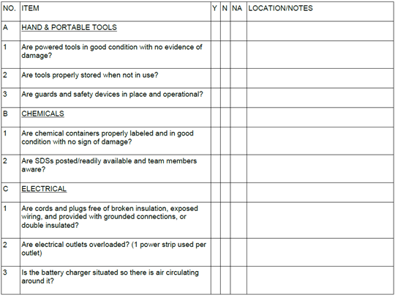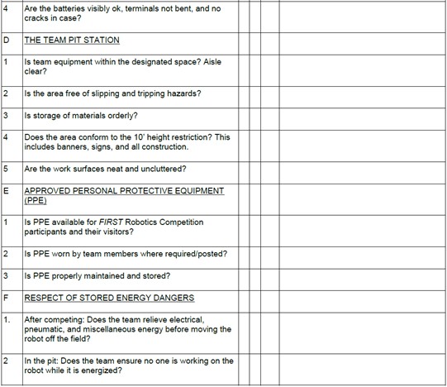

Section D.2: Corrective Action Form

Use this Preventative and Corrective Action Plan to monitor changes your mentor, safety captain, or the
event safety advisor recommends. Include near misses - not just accidents.

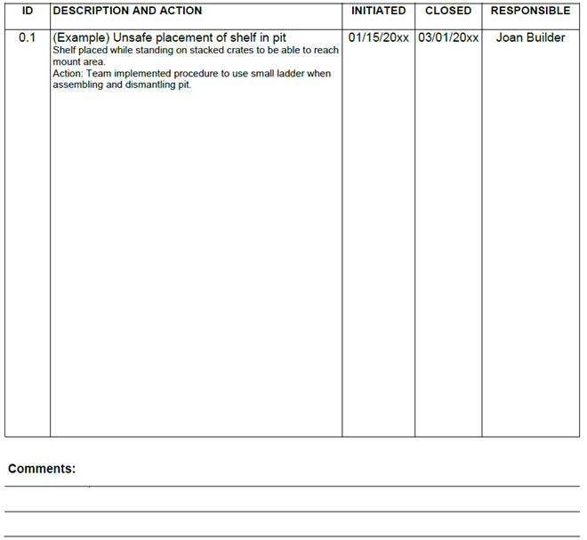

Section D.3: Safety Data Sheets

Each team is responsible to collect, store and make available Safety Data Sheets (SDS) for any chemicals, chemical compounds or chemical mixtures used by the team. SDS information includes instructions for the safe use and potential hazards associated with a particular material or product, and how to react if there is an accident. Students should review a common SDS under the guidance of their coach to understand what it contains and how it can be useful.

SDS sheets can be downloaded from the manufacturer’s web site or by calling the manufacturer directly. Typical chemicals used by FTC teams include:

- Superglue
- WD-40
- Lubricants
- Rubbing Alcohol
- Epoxy

